***How to know the performance of a control system for any input signal ?***

***How to design a control systems which meets the desired response and control requirements ?***

Time domain analysis refers to the analysis of system performance with respect to time i.e., the study of evolution of system variables with time. There are two common ways of analysing the response of systems:

#### Natural Response and Forced Response

1. **Transient Response and Steady State Response**

In both methods, the complete response is given by the combination of both responses i.e., natural and forced responses or transient and steady state responses.

### Natural Response (Zero Input Response):

Natural response is the system’s response to initial conditions with all external forces set to zero.

For example in RLC circuits, this would be the response of the circuit to initial conditions (inductor currents or capacitor voltage) with all the independent voltage and current sources set to zero.

### Forced Response (Zero State Response):

Forced response is the system’s response to external forces with zero initial conditions. For example in case of RLC circuit, this would be the response of the circuit to only external voltage and current source, with zero initial conditions.

1. **Transient Response (** *ytr* (*t* ) **):**

Transient response is a part of complete response in time domain that goes to zero as time tends to infinity. Transient response can be tied to any event that affects the equilibrium of system (disturbance, change in input, etc).

lim

*t* →∞

*ytr* ( *t* ) = 0

1. **Steady State Response (** *yss* (*t* ) **):**

Steady state response is a part of complete response in time domain that exist after transient response practically vanishes and as time goes to infinity.

*y* (*t* ) = *y tr* (*t* ) + *yss* (*t* )

Steady state response could be zero.

# Standard Test Inputs

In most cases, the input signals to a control system are not known prior to design of control system. Hence to analyse the performance of a control system, it is excited with standard test signals. In addition to that the control systems design specifications are also defined based on the response of the system to such test signals.

Standard test signals include:

1. Unit impulse
2. Unit Step (sudden change)
3. Ramp (constant Velocity)
4. Parabolic (Constant acceleration)
5. Sinusoidal

These inputs are chosen because they capture many of the possible variations that occur in an arbitrary input signal.

# First Order System and Response

Systems with only one pole are called first order systems.

*TF* = *Y* ( *s*)

=

*R*( *s*)

1 , this is a standard form for the transfer function of a first order

τ *s* + 1

system.

τ in the above standard form of first order system is a system time constant. The system time constant characterizes the speed of response of a system to an input. Higher the time constant, slower the response and vice versa.

*If we differentiate the parabolic input signal we get ramp signal, on differentiating ramp signal we get step input signal. Similarly if we differentiate response of first order system to parabolic input signal we will get the response of first order system to ramp input signal. If we different response of first order system to ramp signal we will get the response of first order system to step input signal.*

### Impulse Response of First Order System

For impulse response input is a impulse signal, so R(s) = 1

We have standard form of the transfer function for first order system as:

*TF* = *Y* ( *s*)

=

*R*( *s*)

*Y* ( *s*) = 1

1

τ *s* + 1

*R*( *s*) = 1

τ *s* + 1

τ *s* + 1

Taking Inverse Laplace transform on both sides

*y* (*t* ) = *L*−1 [*Y* ( *s*)] = 1 *e*− *t*

τ

##### τ

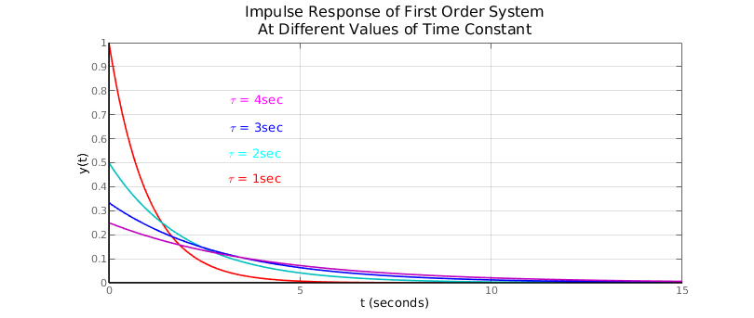

Impulse response of above first order system with different value of time constant τ .

|  |  |  |
| --- | --- | --- |
| τ | = 1 | Blue Curve |
| τ | = 2 | Red Curve |
| τ | = 5 | Yellow Curve |

Higher is time constant slower is the response of the system.

We know that the transient response *ytr* (*t* ) is part of response that goes to zero as the time

approaches infinity. In the system response *y* (*t* ) the term 1 *e*− *t*

τ

vanishes to zero as the time t

approaches infinity. So the term 1 *e*− *t*

τ

τ

in the above impulse response *y* (*t* ) of the first order

##### τ

system is the transient response of the system. Since no other term are present in the impulse

response of the system *y* (*t* ) , the steady state response *yss* (*t* ) of the system in this case is zero.

### Step Response of First Order System

For step response input is a step signal, so *R*( *s*) = *K*

*s*

. K is the magnitude of step input.

We have standard form of the transfer function for first order system as:

*TF* = *Y* ( *s*)

=

*R*( *s*)

*Y* ( *s*) = 1

1

τ *s* + 1

*R*( *s*) = *K*

τ *s* + 1

*s* ( τ *s* + 1 )

Taking Inverse Laplace transform on both sides

*y* (*t* ) = *L*−1 [*Y* ( *s*)] = *K* ( 1 − *e*− *t* )

τ

In above time domain response, both the transient response and steady state response are present

−*t*

*ytr* (*t* ) = −*Ke*τ

*yss* (*t* ) = *K*

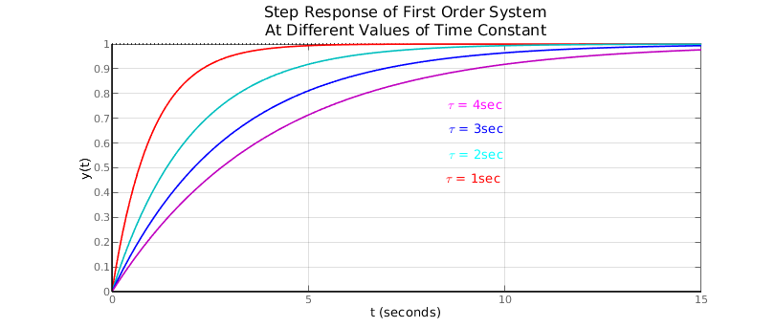

At 4 τ the response will reach about 98.2 % of the steady state value. When the response of the system is within 2% of the final value, it is said that the system is in steady state. So after 4 τ system is said to be in steady state. The 4 τ is sometime defined as the settling time of the system.

The first order system follows the step input signal. So first order system will have zero steady state error when subjected to step input.

### Ramp Response of First Order System

For ramp response, input signal is ramp signal. So *R*( *s*) = *K*

*s*2

, K is the slope of ramp signal.

We have standard form of the transfer function for first order system as:

*TF* = *Y* ( *s*)

=

*R*( *s*)

*Y* ( *s*) = 1

1

τ *s* + 1

*R*( *s*) = *K*

τ *s* + 1

By partial fraction

*Y* ( *s*) = 1 − τ

*s*2 *s*

*s*2 ( τ *s* + 1 )

2

+ τ

( τ *s* + 1 )

Taking Inverse Laplace transform on both sides

*t*

*y* (*t* ) = *L* [*Y* ( *s*)] = *K* (*t* − τ) + τ *K e*− τ

In above response there are both transient response and steady state response.

−*t*

*ytr* (*t* ) = τ *K e*τ

*yss* (*t* ) = *K* (*t* − τ)

So, the first order system will have constant steady state error when subjected to ramp input. The steady state error will be equal to the time constant τ of the system.

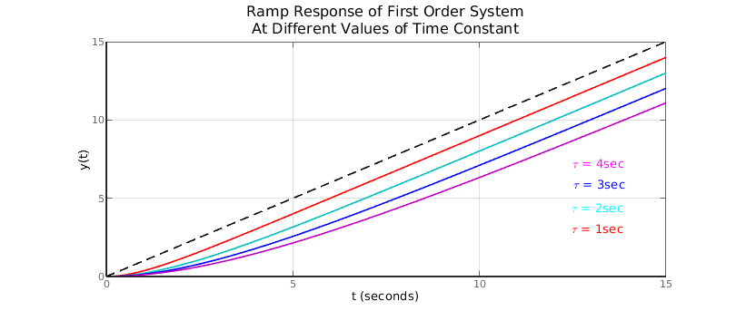

### Parabolic Response of First Order System

For parabolic response input signal is parabolic. So *R*( *s*) = 2 *K*

*s*3

, K is the slope of the parabolic

input signal.

We have standard form of the transfer function for first order system as:

*TF* = *Y* ( *s*)

=

*R*( *s*)

*Y* ( *s*) = 1

1

τ *s* + 1

*R*( *s*) = 2 *K*

τ *s* + 1

By partial fraction

*s*3 ( τ *s* + 1 )

2 3

*Y* ( *s*) = 2 *K*

*s*3

− 2 *K* τ

*s*2

2 *K* τ

*s* −

+

2 *K* τ

( τ *s* + 1 )

Taking Inverse Laplace transform on both sides

*t*

*y* (*t* ) = *L* [*Y* ( *s*)] = *Kt*2 − 2 *K* τ *t* + 2 *K* τ2 − 2 *K* τ2 *e*− τ

In above response there are both transient response and steady state response.

−*t*

*y* (*t* ) = −2 *K* τ2 *e*τ

*tr*

2 2

*yss* (*t* ) = *Kt*

— 2 *K* τ *t* + 2 *K* τ

The first order system will have time dependent increasing steady state error when subjected to parabolic input. The steady state error will be equal to 2 *K* τ *t* − 2 *K* τ2 .

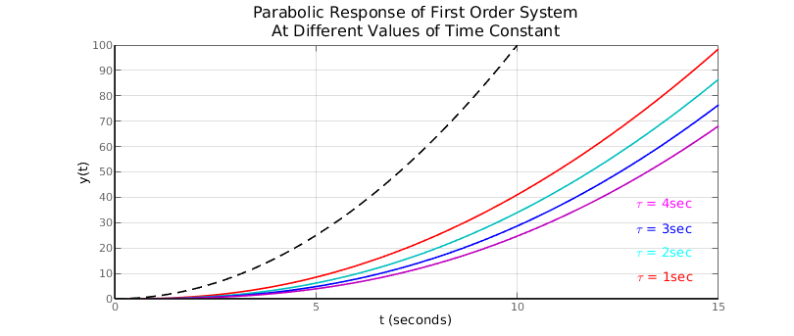

# Second Order System and Response

Systems with two poles are called second order systems. Example RLC circuit or mass-spring- damper system.

In general the transfer function of a second order system can be written as *TF* = *b*

*s*2 + *as* + *b*

To study and understand the response of a second order system, its transfer function is often written

in terms of certain system parameters.

2

*TF* = *Y* ( *s*) (*s* ) = *wn*

is the standard form of transfer function.

*R s*2 + 2 ζ *w*

*n*

*s* + *w* 2

Here, *wn* is called system natural frequency

*n*

ζ is called system damping ratio

System damping ratio ζ is a dimensionless quantity describing the decay of oscillations during a transient response. It is a ratio of actual damping to critical damping of a system.

**System natural frequency** (*wn*) is the angular frequency at which system tends to oscillate in the absence of damping force.

**System damped frequency** *wd* is angular frequency at which system tends to oscillate in the

presence of damping force, *wd*=*wn* √1−ζ .

2

In under damped system the system damped frequency *wd* is less than the natural frequency *wn*

of the system.

Response of second order system mainly depends on the damping ratio ζ . For any test input, the response of second order system can be studied in four cases depending on the damping effect created by value of ζ .

ζ > 1: overdamped system

ζ = 1 : critically damped system

0 < ζ < 1 : Underdamped system

ζ = 0 : undamped system

ζ < 0 : negatively damped system

We are not interested in negatively damped system because negative damping means that the oscillations are increasing in amplitude which results in unstable systems.

## Damping and Types of Damping:

Damping is an effect created in an oscillatory system that reduces, restricts or prevents the oscillations in the system. System can be classified as following depending on damping effect.

###### Over damped Systems:

Transients in the system exponentially decay to steady state without any oscillations.

###### Critically damped System:

Transient in the system decay to steady state without any oscillations in shortest possible time.

###### Under-damped Systems:

System transients oscillate with the amplitude of oscillation gradually decreasing to zero.

###### Undamped Systems:

System keeps on oscillating at its natural frequency without any decay in amplitude.

## Impulse Response of Second Order Systems:

For impulse response input is impulse signal. So, *R*( *s*)=1 .

We have standard form of transfer function for the second order system as

2

*w*

*n*

*Y* ( *s*) =

*n*

*s*2 + 2 ζ *w*

*s* + *w*2 2

*n*

*w*

*n*

*R*( *s*)

∴ *Y* ( *s*) =

*n*

*n*

*s*2 + 2 ζ *w*

*s* + *w*2

**Case-I:** ζ = 0 **, undamped system**

*Y* ( *s*) =

2

*n*

*w*

*s*2 + *w*2

*n*

Taking inverse Laplace transform on both sides, we get

*y* (*t* ) = *wn* sin( *wn t* )

In the above impulse response of undamped second order system only steady state response is present. There is no presence of transient response.

*ytr* (*t* ) = 0

*yss* (*t* ) = *wn* sin( *wn t* )

The undamped second order system will keep on oscillating at its natural frequency when subjected to sudden impulse signal. There is no damping so the system will keep oscillating forever. Higher the natural frequency of the system higher will be the amplitude of the oscillations.

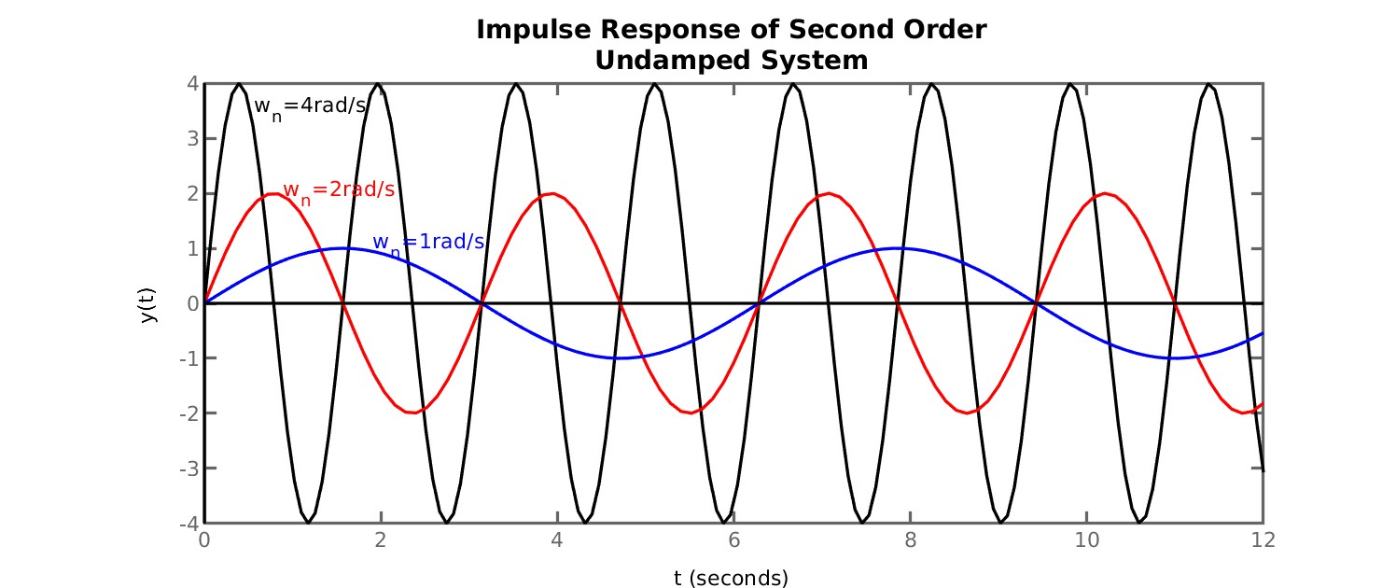

**Case-II:** 0< ζ<1 **, Underdamped System**

*Y* ( *s*) =

2

*n*

*w*

*s*2 + 2 ζ *w*

*n*

*s* + *w* 2

*n*

, the roots of the equation *s*2 + 2 ζ *w*

*n*

*s* + *w*2 are

*n*

*s* = −2 ζ *wn* ± √( 2 ζ *wn*)

2

2 *x* 1

— 4 *x* 1 *xw*2

∴ *s* = −ζ *wn* ± *jwd ;* where *wd* = *wn* √1 − ζ

*n*

2

Now, *Y* ( *s*) =

2

*n*

*w*

( *s* + ζ *wn* − *jwd* ) ( *s* + ζ *wn* + *jwd* )

or, *Y* ( *s*) =

2

*n*

*w*

( *s* + ζ *w* ) 2 2

*n*

*w*

*n*

2 =

— ( *jwd* )

*wd*

2

*n*

*w*

( *s* + ζ *wn* )

2

+ *w*2

*d*

or, *Y* ( *s*) =

× 2

*d* ( *s* + ζ *wn* )

*w*

+ *w* 2

Taking inverse Laplace transform on both sides

*d*

2

*w*

*n* −ζ *w t*

*wn* −ζ *w t*

∴ *y* (*t* ) =

*n*

*w* ×*e*

sin( *wd t* ) =

*e*

√ 1 − ζ2

*n*

sin(*wd t* )

*d*

In the above impulse response of underdamped second order system, only the transient response is present. There will be no steady state response.

*wn* −ζ *w t*

*ytr* (*t* ) =

*n*

*e*

√1 − ζ2

sin(*wd t* )

*yss* (*t* ) = 0

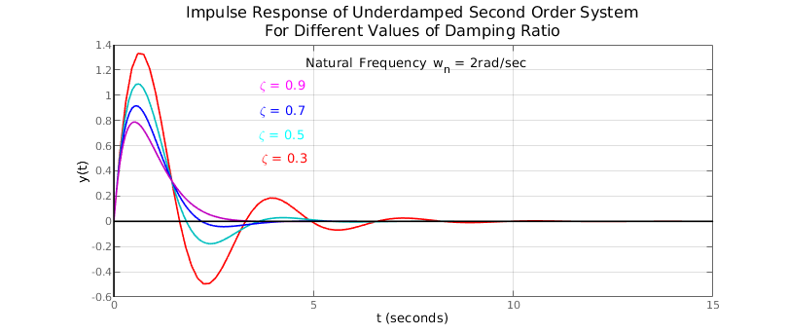

For a given under damped second order system, when the damping is increased, the actual oscillating frequency of the system decreases. For under damped second order system the actual oscillating frequency also known as damped frequency is usually less than the natural frequency of the system.

When the damping is increased the peak overshoot in the system decreases. The number of overshoot and undershoot will be less for the under-damped second order system with higher value of damping.

The settling time of the under-damped second order system will decrease when the damping is increased. Under-damped second order system with low damping will take longer to settle down to a steady state.

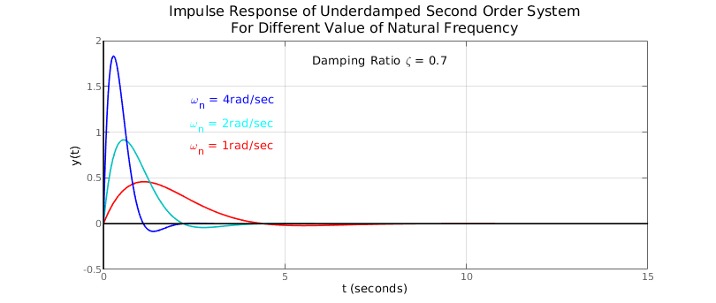

For under-damped second order system with fixed value of damping, the actual oscillation frequency of the system depends on the natural frequency of the system. Higher the natural frequency of the system higher is the actual damped frequency of the system.

The maximum (peak) overshoot of the second order under-damped system with constant damping, depends on the natural frequency of the system. Higher the natural frequency of the system higher will be the peak overshoot of the system.

The maximum amplitude of the response is given by

*y max* (*t p*) = *wn e*

−ζ cos− 1ζ

√

1−ζ2

Clearly for constant value of damping ratio ( ζ ) the peak value of amplitude is dependent only on the natural frequency of the system. Higher the natural frequency of the system higher is the peak amplitude of the second order underdamped system to impulse input.

#### Case-III: ζ = 1 , Critically Damped System:

*Y* ( *s*) =

2

*n*

*w*

*s*2 + 2 *w*

*n*

*s* + *w*2

*n*

, the roots of the equation *s*2 + 2 *w*

*n*

*s* + *w*2 are

*n*

*s*1 *, s*2 = −*wn*

Now, *Y* ( *s*) =

2

*n*

*w*

( *s* + *wn* )

2

Taking Inverse Laplace Transform on both sides

2 −*wnt*

∴ *y* (*t* ) = *wnt e*

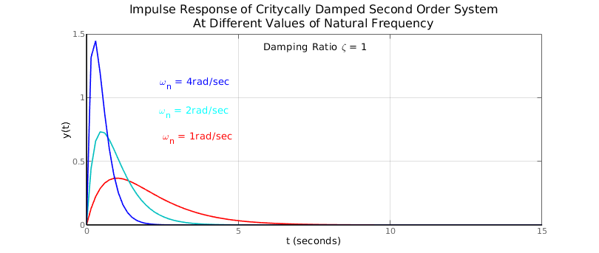

Case-IV: ζ > 1 **, Overdamped System**

*Y* ( *s*) =

2

*n*

*w*

*s*2 + 2 ζ *w*

*n*

*s* + *w* 2

*n*

, the roots of the equation *s*2 + 2 ζ *w*

*n*

*s* + *w*2 are

*n*

*s* = −2 ζ *wn* ± √( 2 ζ *wn*)

2

2 *x* 1

— 4 *x* 1 *xw*2

∴ *s* = −ζ *wn* ± *wn* √ ζ − 1

*n*

2

Now, *Y* ( *s*) =

( *s* + ζ *wn* − *wn* √ ζ

2

*wn*

2

*n*

*w*

— 1 ) ( *s* + ζ *wn* + *wn* √ ζ

2

− 1 )

*wn*

or, *Y* ( *s*) =

× 1 −

× 1

2 √ ζ2 − 1

( *s* + ζ *wn*

— *wn*

√ ζ2 − 1 )

2 √ ζ2 − 1

( *s* + ζ *wn*

+ *wn*

√ ζ2 − 1 )

or, *Y* ( *s*) =

*wn*

2 √ ζ2 − 1 ( *s* + ζ *w*

[

*n*

1

— *wn*

−

√ ζ2 − 1 )

( *s* + ζ *wn*

1

+ *wn*

√ ζ2 − 1 ) ]

Taking inverse Laplace transform on both sides

*wn* (− ζ *w* + *w* √ ζ2 − 1 )*t*

(−ζ *w* − *w* √ ζ2 − 1 ) *t*

∴ *y* (*t* ) =

( *e n n*

2 √ ζ2 − 1

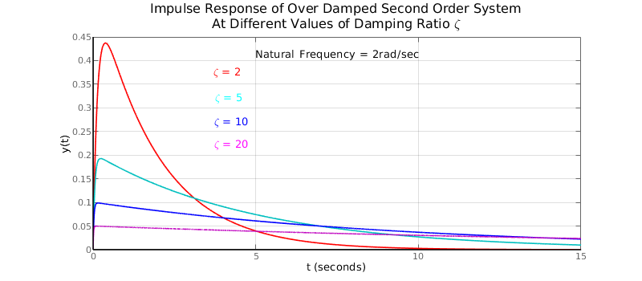

— *e n n* )

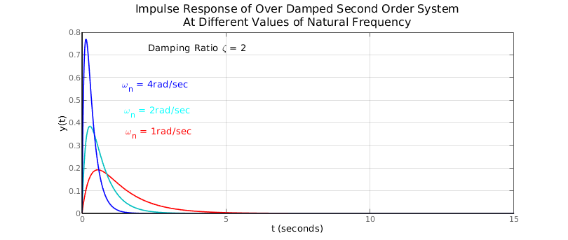

## Step Response of Second Order Systems:

*Y* ( *s*) =

2

*n*

*w*

*s*2 + 2 ζ *w*

*n*

*s* + *w* 2

*n*

*R*( *s*)

For impulse response, *R*( *s*)= 1

*s*

∴ *Y* ( *s*) =

2

*n*

*w*

*s* ( *s*2 + 2 ζ *w*

*n*

*s* + *w*2 )

*n*

**Case-I:** ζ = 0 **, undamped system**

*Y* ( *s*) =

2

*n*

*w*

*s* ( *s*2 + *w*2 )

*n*

Taking inverse Laplace transform on both sides, we get

*y* (*t* ) = 1−cos (*wnt* )

The system will keep on oscillating at its natural frequency when subjected to certain impulse. There is no damping so the system will keep oscillating forever.

**Case-II:** 0< ζ<1 **, Underdamped System**

*Y* ( *s*) =

2

*n*

*w*

*s* ( *s*2 + 2 ζ *w*

*n*

*s* + *w*2 )

*n*

*n*

, the roots of the equation *s*2

+ 2 ζ *w s* + *w*2

*n n*

are

*s* = −2 ζ *wn* ± √( 2 ζ *wn*)

2

2 *x* 1

— 4 *x* 1 *xw*2

∴ *s* = −ζ *wn* ± *jwd ;* where *wd* = *wn* √1 − ζ

2

Now, *Y* ( *s*) =

*s* ( *s* + ζ *wn*

— *jw*

2

*n*

*w*

*d* ) ( *s* + ζ *wn*

+ *jwd* )

or, *Y* ( *s*) =

2 2

*n n*

*w*

*w*

=

2 2 2

*k*1

2 = +

*k*2 *s* + *k*3

2 2

*s* [ ( *s* + ζ *wn* )

— ( *jwd* ) ]

*s* [ ( *s* + ζ *wn* )

+ *wd* ]

*s* ( *s* + ζ *wn* )

+ *wd*

We have, *k*1 *s*

2

+ 2*k* ζ *w s* + *k w* 2

+ *k s*2

+ *k s* = *w*2

Comparing coefficients

1 *n* 1 *n*

2

3 *n*

1 *n* 2 ζ *wn k*1 + *k*3 = 0

*k w*

*n*

= *w*

2 2

*k*1 + *k*2 = 0

∴ *k* 1 = 1

∴ *k* 3 = − 2 ζ *wn*

∴ *k* 2 = −1

∴ *Y* ( *s*) = 1

*s* + ζ *wn*

− 2

ζ *wn wn*

2 − × 2 2

*s* ( *s* + ζ *wn* )

+ *wd*

*wd* ( *s* + ζ *wn* )

+ *wd*

Taking inverse Laplace transform on both sides

or, *y* (*t* ) = 1 − *e*− ζ *wn t* cos( *w*

*d*

ζ *wn* −ζ *w t*

1. ) − ×*e n* sin( *w t* )

*d*

*wd*

* + ζ *wn t*

or, *y* (*t* ) = 1 − *e*

*d*

√1 − ζ2

* + ζ *wn t*

(√1 − ζ2 cos( *w*

*t* ) + ζ sin( *wd*

*t* ))

or, *y* (*t* ) = 1 − *e*

(

√1 − ζ2

−ζ *wnt*

sin θ cos (*wd*

*t* ) + cos θ sin( *wd*

*t* ))

∴ *y* (*t* ) = 1 − *e*

sin( *wd*

*t* + θ )

√1 − ζ2

Where, θ = cos−1 ζ = sin−1( √1 − ζ2)

#### Case-III: ζ = 1 , Critically Damped System:

*Y* ( *s*) =

2

*n*

*w*

*s* ( *s*2 + 2 *w*

*n*

*s* + *w*2 )

*n*

, the roots of the equation *s*2

+ 2 *w s* + *w*2

are

*n n*

*s*1 *, s*2 = −*wn*

Now, *Y* ( *s*) =

2

*n*

*w*

*s* ( *s* + *wn* )

2

Taking Inverse Laplace Transform on both sides

∴ *y* (*t* ) = 1 − *w t e*−*wn t*

*n*

— *e*−*wn t*

#### Case-IV: ζ > 1 , Overdamped System

*Y* ( *s*) =

2

*n*

*w*

*s* ( *s*2 + 2 ζ *w*

*n*

*s* + *w*2 )

*n*

, the roots of the equation *s*2

+ 2 ζ *w s* + *w*2

*n n*

are

*s* = −2 ζ *wn* ± √( 2 ζ *wn*)

2

2 *x* 1

— 4 *x* 1 *xw*2

∴ *s* = −ζ *wn* ± *wn* √ ζ − 1

*n*

2

Now, *Y* ( *s*) =

*s* ( *s* + ζ *wn* − *wn* √ ζ

2

2

*n*

*w*

— 1 ) ( *s* + ζ *wn*

+ *wn* √ ζ

2

− 1 )

or, *Y* ( *s*) = 1 + 1

*x* 1

+ 1

*x* 1

*s* 2 √ζ2 −1 [ √ζ2−1−ζ ]

*n*

(*s* +ζ *wn* −*wn*

√ζ2−1)

2 √ζ2 −1 [ √ζ2−1+ ζ]

( *s*+ ζ *w*

*n* +*w*

√ζ2−1)

Taking inverse Laplace transform on both sides

∴ *y* (*t* ) = 1 + 1

*e*(−ζ *wn* + *wn* √ ζ − 1 )*t* +

2

1

*e*(−ζ *w* − *w* √ ζ − 1 )*t*

2

2√ζ2−1 [√ζ2−1−ζ ]

*n n*

2√ζ2−1 [ √ζ2−1+ζ ]